2010 Meridian Junior College JC2 H1 Chemistry Prelim Paper 2 Answers

Section A

1(a) Quantity of heat released from reaction = -297 x 0.08 = -23.76 kJ

Amount of heat absorbed by water = 0.7 x 23.76 = 16.632 kJ

Temperature changed = 16.632 x 1000/(815 x 4.18) = 4.88 K

Final temperature of water = 28 + 4.88 = 32.9 °C

(b)(i) ΔH_{rxn} = ΔH_{f} (product) – ∑ΔH_{f} (reactants)
ΔH_{rxn} = ΔH_{f} (SO₃) – [ΔH_{f} (SO₂) + ½ΔH_{f} (O₂)]
-98.9 = ΔH_{f} (SO₃) – (-296.9) – 0
ΔH_{f} (SO₃) = -396 kJ mol⁻¹

(ii) ΔH_{rxn} = BE (reactants) - BE (products)
-98.9 = [2 x BE(S=O) + ½BE(O=O)] – 3 x BE(S=O)
-98.9 = ½BE(O=O) – BE(S=O)
BE(S=O) = +98.9 + ½(496) = 346.9 kJ mol⁻¹

The assumption is that the S=O bond has the same bond energy in both SO₂ and SO₃.

(c)(i) Order wrt benzene = 1

Order wrt SO₃ = 2

Rate = k[Benzene][SO₃]²

(ii) 4.29 x 10⁻⁵ = 3.54 x 10⁻⁴ x [Benzene]³ (since [Benzene] = [SO₃])
[Benzene] = (4.29 x 10⁻⁵ / 3.54 x 10⁻⁴)^{1/3} = 0.495 mol dm⁻³
2(a) Mg has a giant metallic structure. Held together by strong electrostatic forces of attraction between Mg²⁺ cations and sea of delocalized electrons.

SiO₂ has a giant molecular structure. Held together by strong and extensive covalent bonding between the atoms in a giant 3-dimensional network.

PCl₅ has a simple molecular structure. Held together by van der Waal’s forces of attraction between PCl₅ molecules.

(b) Size of molecule: PCl₃ < PCl₅
Size of electron cloud: PCl₃ < PCl₅
Degree of distortion of electron cloud : PCl₃ < PCl₅
Extent of intermolecular van der Waal’s forces: PCl₃ < PCl₅
Energy required to overcome: PCl₃ < PCl₅
Melting point: PCl₃ < PCl₅
Hence, PCl₃ liquid, PCl₅ solid.

(c)(i) Mg burns in oxygen very vigorously with a bright white flame to produce white solid.

(ii) MgO + 2HCl → MgCl₂ + H₂O

MgO + NaOH → no reaction

(d) SiO₂
Does not react with water due to its very stable giant molecular structure.

PCl₅
Undergoes complete hydrolysis to form pH=2.0 / strongly acidic solution.

PCl₅ + H₂O → POCl₃ + 2HCl (cold)
or
PCl₅ + 4H₂O → H₃PO₄ + 5HCl (hot)

(e) Be has a diagonal relationship / similar charge density with Al instead, due to similar charge densities of Be²⁺ and Al^{3+,} hence is amphoteric and will also react with a base unlike MgO in part(c)(ii).

3(a)(i) K_{c} = [O₂]³/[O₃]²

K_{c} = 650³/[300]²
= 3.05 x 10³ DU

(ii) 120 DU

(iii) New K_{c} = (650)³/(120)² = 1.91 x 10⁴ DU

(iv) Global warming/There is a change in global temperature.

(b) There is no change in the equilibrium of the reaction because the number of moles of gaseous reactants is the same as the number of moles of gaseous product hence the equilibrium position will not change with the change in pressure.

4(a)(i)
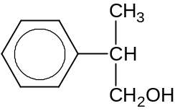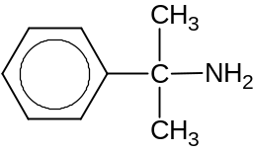
conc. H₃PO₄ /
conc H₂SO₄ / Al₂O₃
and heat
Excess NH₃ (g), heat in sealed tube

rtp

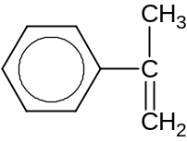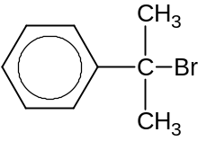
HBr (g)/in CCl₄
rtp

(ii) Any value < 50%

(b)
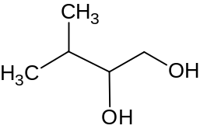 N 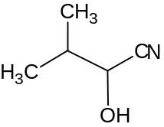 Q

Step 1: KMnO₄ in dilute H₂SO₄; heat
Step 2: NaBH₄ in ethanol, rtp
Step 3: K₂Cr₂O₇ in dilute H₂SO₄ heat with distillation
Step 4: HCN, trace aq NaOH, cold

(c)(i) Test : Add 2,4-DNPH with heating to the two unknown in separate test tubes.

Observation: Orange crystals of hydrazone is formed for the test-tube containing A. No orange ppt will be formed for the test-tube containing B.

(ii) Test: Add aqueous alkaline iodine with heating to the two unknown in separate test-tubes.

Observation & deduction: Yellow ppt of CHI₃ formed for the test-tube containing C. No yellow ppt of CHI₃ formed for the test-tube containing D.

Section B

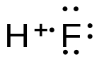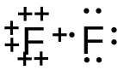5(a)(i)

(ii) The increasing H-X bond length from H-F to H-I.

(iii) The repulsion between the lone pairs of the two F atoms weakens the bond.

(iv) Any value > -50.8 ºC (but must be able to exist as gas at r.t.p)

HF has strong intermolecular hydrogen bonding which requires more energy to overcome as compared to the weaker intermolecular Van Der Waals forces of attraction for HCl, HBr and HI. Hence higher boiling point.

(b)(i) pH = log₁₀[H⁺]

(ii) [HF] = 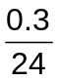= 0.0125 mol dm⁻³

[H⁺] = 1 x 10⁻³ mol dm⁻³

Since [H⁺] << [HF] or [H⁺] partially dissociated
HF is a weak acid.

(c)(i) Graph 2. The salt formed, NaF, contains a conjugate base, F⁻. Therefore the equivalent point of the titration will be > 7.

(ii) Vol of NaOH added No. of moles of HX

Since Vol of NaOH added to titrate HF > Vol of NaOH to titrate HCl
No. of moles of HF > No. of moles of HCl
As volume of HF and HCl is the same
[HF] > [HCl]

(iii) Phenolphthalein

The pH transition range of phenolphthalein lies within the rapid pH change over the equivalence point.

(d)(i) Some of the heat released by the neutralization between the weak acid, CH₃COOH and NaOH is absorbed to further dissociate CH₃COOH. Thus the temperature rise is higher for the reaction between HCl and NaOH as no such heat is absorbed.

(ii) By Le Chatelier’s Principle, at higher temperature, endothermic reaction is favoured. Therefore the equilibrium position shifts to the right to absorb heat. The dissociation of CH₃COOH is greater thus less heat is absorbed resulting in a larger temperature rise recorded.

(e) When a small amount of H₂SO₄ is added,

CH₃COO⁻ + H⁺ → CH₃COOH

H⁺ is removed as CH₃COOH.
[H⁺] is slightly changed and pH of the solution remains fairly constant.

6(a)(i) X²⁺ - P4 X³⁺ - P5 S²⁻ - P1/P2
(ii) 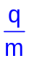ratio of S²⁻ = 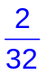= 0.0625
let the ratio of X²⁺ be y
since angle of deflection
 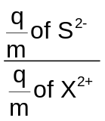=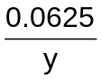=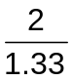
⇒ y = 0.0416 = 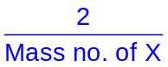
Mass no. of X = 48.0

Proton no. of X = Mass no. – no. of neutrons
= 48 – 25
= 23

X is Vanadium.

(b)(i) SF₄ has 4 bond pairs and 1 lone pair around the central S atom .
To minimize repulsion and maximize stability , the 5 electron pairs are directed to the corners of a trigonal bipyramidal
But lone pair – bond pair repulsion > bond pair – bond pair repulsion
Shape is distorted tetrahedral

SF₄ has 6 bond pairs and 0 lone pair around the central S atom
To minimize repulsion and maximize stability, the 6 electrons pairs are directed to the corners of a octahedron
Shape is octahedral

(ii) SF₄ is polar and SF₆ is non-polar

(iii) SF₄ has stronger permanent dipole – permanent dipole intermolecular forces of attraction which requires higher amount of energy to overcome as compared to the weaker induced dipole – induced dipole intermolecular forces of attraction of SF₆.
(iv) O is in Period 2 and does not have energetically available and accessible d orbitals to expand beyond the octet structure

(c)(i) A catalyst is a substance that increases the rate of a chemical reaction without itself being consumed.

(ii) The catalyst provides an alternative reaction pathway with a lower activation energy. Thus there are more reactant particles with energy > E_{a} and the frequency of effective collisions increases. Since rate is proportional to frequency of effective collisions, rate increases.

(iii) Intermediate – C
Catalyst – D

(iv)
[A]
[time]

7(a)(i) 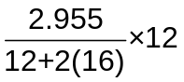 = 0.806 g

(ii) H₂O ≡ 2H

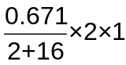 = 0.0746 g

(iii) Mass of O = (2.955 + 0.671) – (0.806 + 0.0746)
= 2.75 g

(iv) E contains oxygen atoms.

(v) Mass of O in 1 g E = 2.75 – 2.63 = 0.120 g

C H O
No. of mol 0.0672 0.0746 0.00750
Mole ratio 9 10 1

Molecular formula: C₉H₁₀O

(vi) C₉H₁₀O + 11 O₂ → 9 CO₂ + 5 H₂O

(b) T is neutral
⇒ T is not a carboxylic acid

T undergoes substitution with PCl₅ to form U,
⇒ T is an alcohol

U undergoes basic hydrolysis with hot NaOH(aq) to form CH₃COONa and V,
⇒ U is an ester
⇒ V is an alcohol

V undergoes substitution with KCN to form W
⇒ W contains a nitrile group
⇒ V is a halogenoalkane group

W undergoes acid hydrolysis with dilute H₂SO₄ to form X.
⇒ X is a carboxylic acid

X undergoes self-esterification on heating to form Y.
⇒ Y is an ester
⇒ X is an alcohol

X undergoes oxidation to form Z
Z undergoes neutralization/acid-carbonate reaction with sodium carbonate.
⇒ X is a primary alcohol.
⇒ Z is a dicarboxylic acid.

Structure of T is HOCH₂CH₂CH₂OCOCH₃

Structure of U is ClCH₂CH₂CH₂OCOCH₃

Structure of V is ClCH₂CH₂CH₂OH

Structure of W is HOCH₂CH₂CH₂CN

Structure of X is HOCH₂CH₂CH₂COOH

Structure of Y is 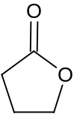
Structure of Z is HOOCCH₂CH₂COOH

